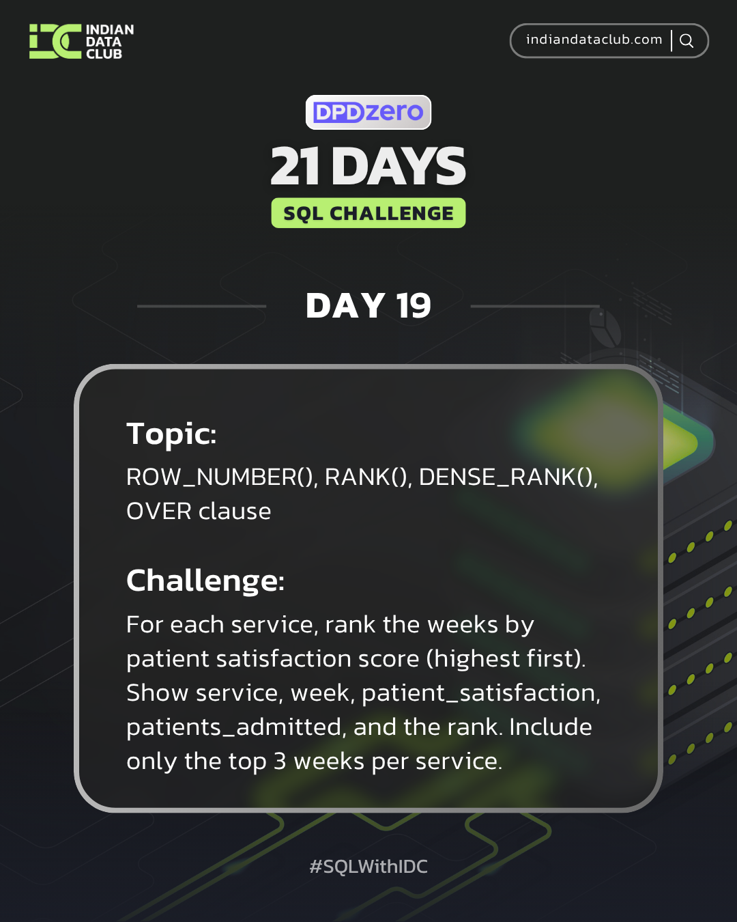

Day-19 SQL Challenge
Day-19 Challenge:
For each service, rank the weeks by patient satisfaction score (highest first). Show service, week, patient_satisfaction, patients_admitted, and the rank. Include only the top 3 weeks per service.
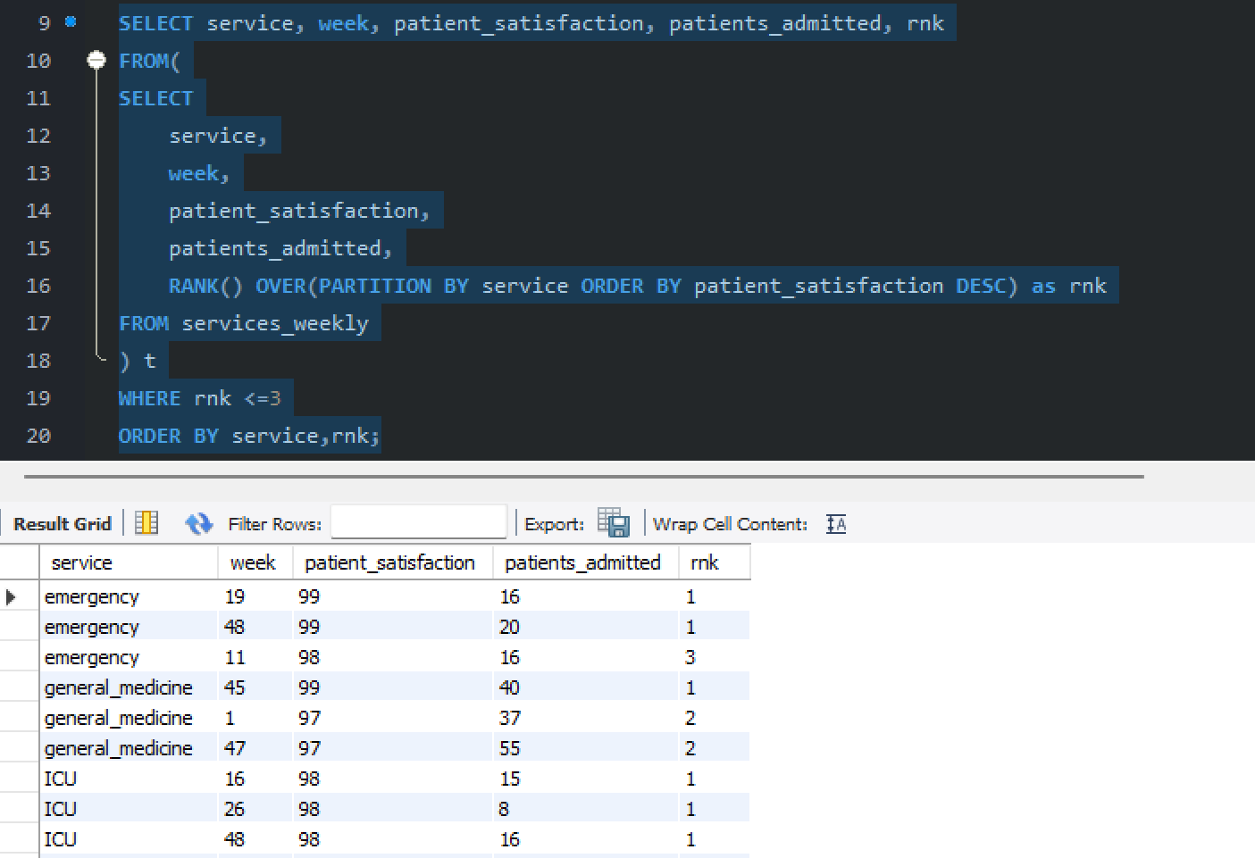

Practise Questions:
1. Rank patients by satisfaction score within each service.
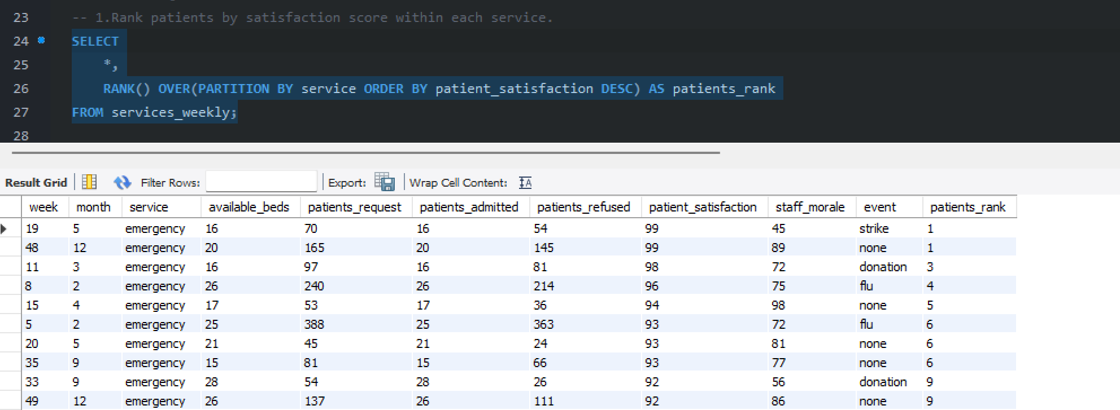

2. Assign row numbers to staff ordered by their name.
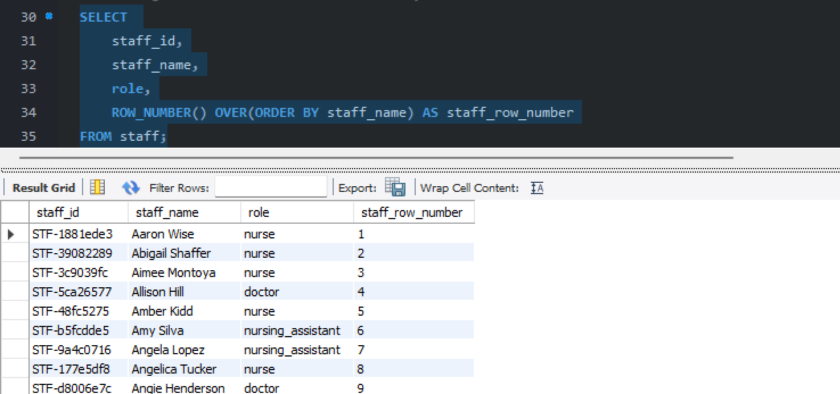

3. Rank services by total patients admitted.
